Supervised e-Learning is a “MUST”
Haitham A. El-Ghareeb
Associate Lecturer, Information Systems Department, Faculty of Computers and Information Sciences, Mansoura University, Egypt.
helghareeb@acm.org

Introduction and Problem Highlights
One of the courses currently taught in Faculty of Computers and Information Sciences in Mansoura University of Egypt (http://csimu.mans.edu.eg) in academic year 2008/2009 is “Information Systems Analysis and Design”. This course utilizes different features of learning and e-Learning activities. One of the utilized e-Learning activities is “Online Assessments”. Though Online Assessments is not the only criteria to qualify students, it is still an important feature to be activated because of the many advantages of enhancing learning experience, automated assessments marking, assessments and assessments’ items analysis, and students’ profiles features. However, one of the problems that prevent us from gaining advantages of online assessments is “Leak of Assessments”. Students search the WWW for assessments’ questions and answers, and unfortunately they can easily find them. Screenshots of questions, answers, final grade of those answers, and attendance date of assessment are the data available as search results. Of course it is students’ choice to follow those answers or not. No matter how close you are; as an instructor, to students, they will not confess “cheating”. Online assessments are not conducted in a secure and supervised environment in the Faculty. Argues that Distance Learning is based on providing different activities for away students convinced some professors to give students online assessments from home, typically as the case with distance learning students. During my analysis of the “First Assessment” and “Second Assessment” results, some facts became clear to me. One of the results that forced me to analyse assessments data was the noticeable number of students who finished the assessment in less than 10 minutes and acquired more than 30 out of 50 as a mark. Both assessments consist of 50 True/False questions. Those questions are very well prepared; some of them are available via the resources available from the book author(s), and the rest are prepared internally. It was shocking to find that number of students with high grades in an almost “not enough time to read the questions” is high. Luckily students do not know that the system records start-time, end-time, and can easily calculate duration or they would have spent longer times just pretending to be solving the assessment.

Problem Domain Analysis
This study holds the analysis results of first assessment; which is not so far different from second one. Figure 1 presents the percentage of students with variant assessment completion times. There are 223 students enrolled in this course with 209 online active users. Number of students attended the first assessment is 182.
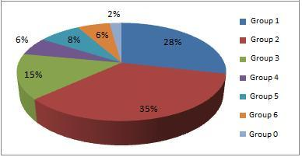
Figure 1: Percentage of Students Per Assessment Time
Students can be classified into 7 groups based on the assessment time as presented in table 1. The strange notice was that almost 2/3 of the students conducted the assessment in less than 20 min. and that indicates an alarm.
Table 1: Different Students Groups in this Study
Group 1 | Students conducted the assessment in duration between 0 and 10 min.
Group 2 | Students conducted the assessment in duration between 10 and 20 min.
Group 3 | Students conducted the assessment in duration between 20 and 30 min.
Group 4 | Students conducted the assessment in duration between 30 and 40 min.
Group 5 | Students conducted the assessment in duration between 40 and 50 min.
Group 6 | Students conducted the assessment in duration between 50 and 60 min.
Group 0 | Students started but did not complete the assessment and will not be mentioned anymore in this study
To verify the situation, the marks average of each group was calculated and again the results clearly indicate something that is not as “planned to be” situation. Figure 2 depicts the average of the six different groups with the notice that averages are almost the same. That means there are students who solved the assessment in less than 10 min. with marks close to; and may exceed sometimes, those who solved it in almost an hour.
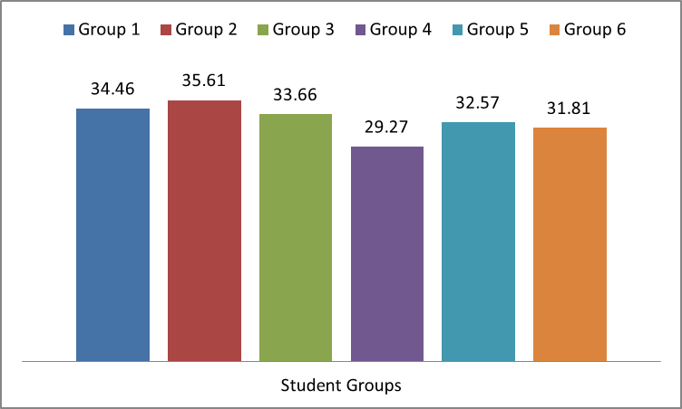
Figure 2: Bar Graph of Marks Average Per Different Student Groups
To be sure about the grading issue, further analysis to the results was applied with the result that: no. of students from all groups who scored between 0 and 10 out of 50 is (zero), no. of students from all groups who scored between 10 and 20 is only (one). Figure 3 shows the different counts of different groups for marks between 20 and 30. Figure 4 and figure 5 shows the different number of students with marks between 30 and 40, and 40 and 50 respectively.
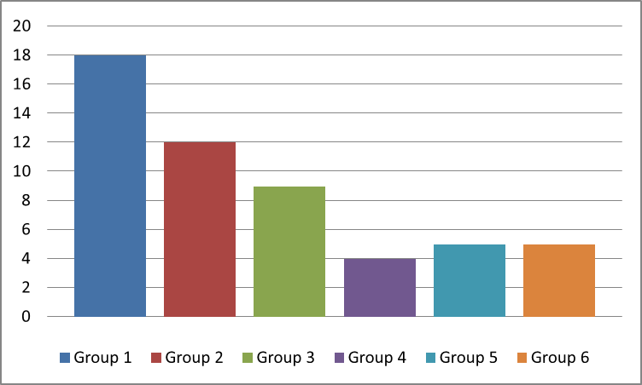
Figure 3: Bar Graph of No. of Students Achieving Grade Range from 20 to 30 Categorized by Group

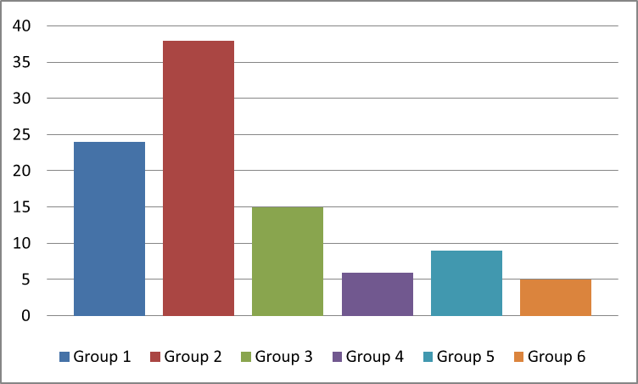
Figure 4: Bar Graph of No. of Students Achieving Grade Range from 30 to 40 Categorized by Group
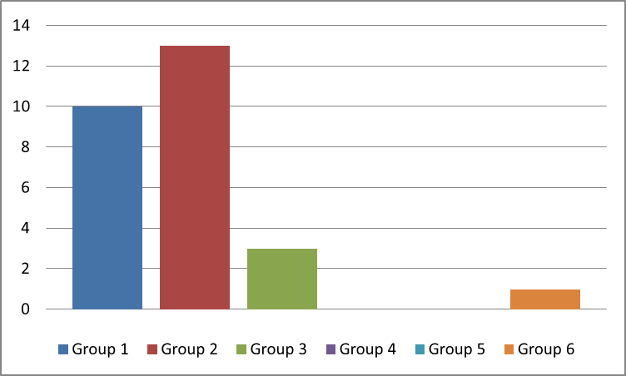
Figure 5: Bar Graph of No. of Students Achieving Grade Range from 40 to 50 Categorized by Group

Comments on Results
Here are some cheating tips I have witnessed myself or through students’ monitoring and feedback:
- Access to Answers’ Files: Open the pdf or document file of the assessment, search for keywords, and immediately apply answers. Most students have high memorable capabilities regarding mapping questions and answers.
- Collaborative Solution: Though collaboration is really important in the learning process, but this way of collaboration to cheat was really new to me. More than one student conducts the assessment. One holds the laptop, others hold different pages of the assessment answers; so they optimize the search time, and the one holding the laptop says the question loudly and of course students can find answers within no time. Of course in Non-Supervised e-Learning environment, there is no way to guarantee that students themselves attended the assessment.
Two categories of Students must not be neglected to assure certain learning quality level:
- Careless Students: They don’t really need to read the assessment questions. They only pick an answer and they don’t care about the results. There are students who answered 50 questions in less than 3 minutes, which gives them an average reading of 3.6 seconds for each question. Another form of careless was presented in the 4 students (out of 182 that is almost 2%) who did not finalize the assessment though they started it.
- Not Interested Students: Almost 23% of the course enrolled students (41 students out of total 223 students) did not attend any of the e-Learning activities. This percentage is huge, and in our course it is not acceptable at all. However, motivating students to attend
e-Learning activities is always a challenge.

Proposed Solution and Conclusion
Based on results presented in the introduction section, it is clear that there are issues that shall be considered before providing students with online exams. There must be a stronger way of controlling the Exam process; in order to make marks more trustable. Proposed Solution tips to this issue are many. More studies about efficiency and effectiveness of each one needs to be conducted and further analysed and studied. Those actions can be categorized into two categories: educational and technical solutions. Solution include: Pedagogical and Technical aspects.

Pedagogical Proposed Solution Aspects
Educational Solutions include the attempt to present an unlimited Assessment Items Repository, and to track student progress during the learning process, so peaks can be determined and they might be a mark for inappropriate activity during the learning process. Also, a timed question is almost a must in the exam process. Timer shall not only start after the student sees the question, we are thinking about calculating time for both displaying and solving the question, so theoretically, students shall never find time to cheat.
This study proposes some tips that can be used as solutions that focuses on four aspects of the online assessment process and can be thought of as the integration of the four of them:
- Questions Based Solution: Assessments banks should consist from larger no. of questions with the chance to have ¼ or 1/3 of the assessment different for each student than others. Also, instructors shall work on updating assessments’ banks and keeping it out of student reach.
- Environment Based Solution: This solution is complimentary to the aforementioned suggested one. Supervised e-Learning environments are important and simply they are the only way to guarantee certain accepted level of learning quality. Students can find the time to search the answer files because they simply have the access to them. Hopefully when students don’t have access to such files, they might learn better.
- Assessment Based Solution: Timer that forces students to read questions before viewing the answers might be a good idea. Maybe by forcing student to wait for answers before s/he can choose one of them will be a catalyst for the student to read the questions and all the answers. Though this is not a guarantee, but it might be a good way to do so.
- Student Based Solution: Talking to students about the importance of e-Learning activities in the learning process and about the gains they can easily acquire and make use of via utilizing such activities is important. The attempt to qualify students’ culture with e-Learning is important to start gaining e-Learning advantages. Not all students yet believe in
e-Learning; only 182 out of 223 cared about attending the online course activities. The rest needs to be talked to; instead of just be neglected.
Most of nowadays students do their best to play it smart, even if they will not follow the rules. Solutions to guarantee learning efficiency and effectiveness for current situations must be thought of about regularly. Unfortunately students usually advance instructors in utilizing technology for their purposes; which might be “cheating”. We; as instructors, need to evaluate the situation regularly and rely more on student performance analysis tools to find facts that are not clear to us.

Technical Aspects of the Solution
Technical Solutions are a real challenge. There is no Web based assessment system that presented a clear solution to such a problem. Solution lies in a well-controlled desktop application that must be used in the Exam process. Desktop applications provide techniques that are not available via Web based systems. Those techniques include:
- Keyboard Hooking: Desktop application can control keyboard strikes on system basis; not on application basis. So, we can control which keys are available for students to click, and which are not. However, such solution is applicable for Microsoft Windows based Desktop Applications only; because Java Virtual Machine (JVM) doesn’t provide such control over Operating System, and that will stop authors from developing a platform independent Exam Desktop Application.
- Operating System Log File: Desktop application can check the Operating System Log file, and when it finds that student executed any of the non-authored applications during the exam, it exits the exam. However, students can be smart enough to use two computers during the exam: one for taking the exam, and another for cheating. Besides, checking the Log file will be a time based process that is not guaranteed to take place anytime.
- Check Running Processes: Desktop application will check the running processes on the system before and during the exam, and will exit any non-exam required process that is running during the exam. This technique seems to be the most appropriate one; however building this list of processes will take time and effort.
By combining the aforementioned techniques; both educational and technical, we might get a better circumstances during exams, and hopefully results will be available soon “after applying the exam to students, recording and analysing statistics”.

